

**TECHNO INDIA UNIVERSITY**

**SUSTAINABLESHOP BLUEPRINT: ORGANIC FARMING**

SOFTWARE REQUIRMENT SPECIFICATION

**[SRS]**

4TH June 2024

Prepared for

Software Engineering Lab

1. **Introduction** 
   1. **Purpose**

The purpose of this Software Requirements Specification (SRS) document is to provide a detailed description of the functionalities, constraints, and requirements for the development of an e-commerce website dedicated to organic farming products. This document serves as a guide for developers, project managers, and stakeholders involved in the project, ensuring a clear understanding of the system's objectives and capabilities.

It provides a comprehensive guide for the development of an e-commerce website focused on organic farming. This website, named **"Sustainableshop Blueprint: Organic Farming"**, will serve as a complete platform for both organic product producers (farmers) and customers (wholesalers, retailers, and consumers). The system will have four types of users: admin, producer (farmer), sales person (wholesalers and retailers), and consumers.

**Admin** will be responsible for updating the platform with new features and providing information about the latest organic farming techniques, market prices, and success stories of farmers to motivate others in the field of organic agriculture. **Producers (farmers)** can advertise their organic products with details such as product name, price, quantity, and available locations, based on the admin's posts. **Sales persons** (wholesalers and retailers) and **consumers** can post their needs, including the desired product details and required locations.

This platform aims to connect producers and customers, facilitate the buying and selling of organic products, provide up-to-date information and requirements for commercial organic farming, share market insights for organic agricultural products, and highlight success stories to inspire individuals in the organic farming industry.

* 1. **Problem Definition**

The organic farming industry faces significant challenges in reaching a broader market and ensuring fair pricing for both producers and consumers. Traditional supply chains for organic products often involve multiple intermediaries, which can lead to inflated prices for consumers and reduced profits for farmers. Additionally, the lack of a centralized platform where farmers can directly advertise their organic products and connect with potential buyers limits their market reach and visibility. This fragmented market structure not only hampers the growth of organic farming but also prevents consumers from accessing high-quality, affordable organic products.

Furthermore, consumers and retailers seeking organic products frequently struggle with finding reliable sources and verifying the authenticity of organic claims. Current platforms do not provide sufficient information about organic farming techniques, market trends, or the success stories that could motivate new entrants into the organic farming sector. This gap in information flow and connectivity results in a disconnect between the demand for and supply of organic products, ultimately stifling the potential growth and sustainability of the organic farming market. An integrated e-commerce solution is needed to bridge this gap, providing a transparent, efficient, and supportive environment for both organic farmers and consumers.

* 1. **Objective**

The primary objective of this SRS document is to provide a comprehensive and detailed blueprint for the development of **Sustainableshop Blueprint: Organic Farming**, an e-commerce platform dedicated to organic farming. This document aims to clearly define the functional and non-functional requirements of the system, ensuring that all stakeholders, including developers, project managers, and users, have a shared understanding of the project goals and expectations. By outlining the specific features, user roles, and interactions within the platform, this SRS aims to guide the development process, ensuring that the final product meets the needs of organic farmers, wholesalers, retailers, and consumers.

Additionally, this SRS document seeks to address the key challenges faced by the organic farming industry by proposing a solution that enhances market accessibility, transparency, and efficiency. By detailing the technical specifications, performance criteria, and security requirements, the document aims to ensure that **Sustainableshop Blueprint: Organic Farming** is not only user-friendly and robust but also scalable and secure. The ultimate objective is to create a platform that supports the sustainable growth of the organic farming sector, facilitates direct connections between producers and consumers, and provides valuable information to promote best practices in organic agriculture.

* 1. **Scope**

The scope of **Sustainableshop Blueprint: Organic Farming** encompasses the development, deployment, and maintenance of an e-commerce platform specifically designed to support and enhance the organic farming industry. The platform will facilitate direct interactions between organic product producers (farmers) and customers (wholesalers, retailers, and consumers), providing a centralized marketplace that promotes fair pricing, transparency, and accessibility.

* + 1. **User Roles and Responsibilities**

**Admin:**

* + Admins will manage the overall platform operations, including updating the website with new features, posting relevant information about the latest organic farming techniques, market trends, and success stories.
  + Admins will be responsible for maintaining the quality and accuracy of the content, ensuring compliance with regulatory standards, and addressing any technical issues that arise.
  + Admins will also handle user management, including approving new registrations, moderating user-generated content, and resolving disputes between parties.

**Producers (Farmers):**

* + Farmers will use the platform to list and advertise their organic products, providing detailed information such as product name, price, quantity, and availability.
  + They will be able to update their listings based on real-time market conditions and respond to inquiries from potential buyers.
  + Farmers will also have access to resources and articles posted by admins, helping them stay informed about best practices and innovations in organic farming.

**Sales Persons (Wholesalers and Retailers):**

* + Wholesalers and retailers will be able to browse listings, post their product needs, and connect with producers to negotiate deals.
  + They will have tools to manage their orders, track shipments, and communicate with both producers and consumers to ensure smooth transactions.
  + Sales persons will also benefit from market insights and trend analyses provided by the platform, enabling them to make informed purchasing decisions.

**Consumers:**

* + Consumers will have access to a wide range of organic products, with the ability to search, filter, and compare items based on various criteria such as price, rating, and availability.
  + They will be able to place orders, make payments securely, and track their deliveries through the platform.
  + Consumers can also leave reviews and ratings for products and sellers, contributing to the overall transparency and trustworthiness of the marketplace.
    1. **Functional Scope**

**User Registration and Authentication:**

* + The platform will support secure user registration and login, with options for password recovery and two-factor authentication to enhance security.

**Product Listings and Search:**

* + Farmers can create detailed product listings, while buyers can search and filter products based on various attributes.
  + Advanced search functionality will enable users to quickly find specific products or categories.

**Shopping Cart and Checkout:**

* + Consumers can add products to a virtual shopping cart, update quantities, and proceed to checkout, where they can enter shipping details and make payments.
  + The checkout process will integrate with multiple payment gateways to ensure secure transactions.

**Order Management:**

* + Both producers and buyers will have tools to manage their orders, including order tracking, status updates, and communication features.
  + The platform will support order history and reporting features for better management and transparency.

**Review and Rating System:**

* + Users can leave reviews and ratings for products and sellers, helping to build trust and guide future purchasing decisions.
  + Admins will moderate reviews to ensure compliance with community guidelines.

**Admin Dashboard:**

* + The admin dashboard will provide comprehensive tools for managing the platform, including user management, content moderation, and analytics.
  + Admins will be able to generate reports on platform usage, sales trends, and other key metrics.
    1. **Non-Functional Scope**

**Performance and Scalability:**

* + The platform will be designed to handle high traffic volumes and support up to 10,000 concurrent users without significant performance degradation.
  + Scalability features will allow the platform to grow and accommodate increasing numbers of users and transactions over time.

**Security and Compliance:**

* + Data encryption and secure communication protocols will be implemented to protect user information and transaction data.
  + The platform will comply with relevant data protection regulations, such as GDPR and CCPA, ensuring user privacy and security.

**Usability and Accessibility:**

* + The user interface will be intuitive and easy to navigate, with a focus on delivering a seamless user experience across both desktop and mobile devices.
  + The platform will adhere to WCAG standards to ensure accessibility for users with disabilities.

**Reliability and Maintenance:**

* + The platform will aim for 99.9% uptime, with robust backup and disaster recovery plans in place to ensure data integrity and availability.
  + Regular maintenance and updates will be conducted to keep the system secure and up-to-date with the latest features and improvements.

By encompassing these functional and non-functional aspects, **Sustainableshop Blueprint: Organic Farming** aims to create a comprehensive, user-friendly, and secure platform that supports the sustainable growth of the organic farming industry, facilitates direct connections between producers and consumers, and provides valuable information to promote best practices in organic agriculture.

**1.5 References**

This section lists the documents, standards, and other resources that are referenced in this Software Requirements Specification (SRS) document. These references provide additional context, guidelines, and requirements that are essential for the development of **Sustainableshop Blueprint: Organic Farming.**

**1.5.1 Standards and Guidelines**

* **IEEE Std 830-1998**: IEEE Recommended Practice for Software Requirements Specifications. This standard provides guidelines for the structure and content of an SRS document, ensuring completeness and clarity.
* **GDPR (General Data Protection Regulation)**: A European Union regulation that governs data protection and privacy for individuals within the EU and the European Economic Area. Compliance with GDPR is critical for handling user data securely and legally.
* **CCPA (California Consumer Privacy Act)**: A state statute intended to enhance privacy rights and consumer protection for residents of California, USA. Ensuring compliance with CCPA is essential for managing the personal data of users from California.
* **WCAG (Web Content Accessibility Guidelines)**: Guidelines developed by the World Wide Web Consortium (W3C) for making web content more accessible to people with disabilities. Adhering to WCAG standards is crucial for creating an inclusive platform that can be used by all users, regardless of their abilities.

**1.5.2 Technical References**

* **HTML5, CSS3, and JavaScript Standards**: Specifications and best practices for web development technologies that will be used to build the user interface of the platform. Following these standards ensures compatibility and performance across different browsers and devices.
* **Payment Gateway Documentation (e.g., PayPal, Stripe)**: Official documentation and integration guides provided by payment gateway services. These references are essential for implementing secure and reliable payment processing within the platform.

**1.5.3 Regulatory References**

* **Data Protection Laws**: National and international data protection regulations that govern the collection, storage, and processing of personal data. Compliance with these laws is mandatory to protect user privacy and avoid legal repercussions.

**1.5.4 Industry Best Practices**

* **E-commerce Best Practices**: Guidelines and strategies for building and managing successful e-commerce platforms. These best practices cover various aspects, including user experience design, security measures, and performance optimization.
* **Organic Farming Resources**: Publications, research papers, and case studies related to organic farming. These resources provide valuable insights and information that will be shared with users on the platform to promote best practices in organic agriculture.

**1.5.5 Supporting Documentation**

* **User Manuals**: Detailed guides and instructions for users on how to navigate and use the platform's features. These manuals will be developed and maintained to help users make the most of the platform.
* **Online Help and FAQs**: Context-sensitive help articles and frequently asked questions that provide immediate assistance to users. These resources will be updated regularly based on user feedback and common queries.

By referencing these standards, guidelines, and resources, this SRS document aims to ensure that **Sustainableshop Blueprint: Organic Farming** is developed in accordance with industry best practices, regulatory requirements, and user expectations. These references provide the foundational knowledge and frameworks necessary for building a robust, secure, and user-friendly e-commerce platform for organic farming.

1. **General Description**

**2.1 Product Perspective**

**Sustainableshop Blueprint: Organic Farming** is a web-based e-commerce platform designed to facilitate the buying and selling of organic farming products. It operates as a centralized marketplace, bridging the gap between organic farmers (producers) and customers (wholesalers, retailers, and consumers). The system integrates various functionalities to ensure a seamless user experience, from product listing and search to secure payment processing and order management. **Sustainableshop Blueprint: Organic Farming** stands out by providing not only a marketplace but also valuable resources and information on organic farming techniques, market trends, and success stories.

**2.2 Product Functions**

* **User Registration and Authentication**: Secure user registration, login, password recovery, and two-factor authentication.
* **Product Listings**: Producers can create and manage product listings with detailed information such as name, price, quantity, and location.
* **Search and Filtering**: Advanced search functionality and filters for product categories, price range, ratings, and availability.
* **Shopping Cart and Checkout**: Users can add products to a shopping cart, update quantities, proceed to checkout, and make secure payments.
* **Order Management**: Tools for producers and buyers to manage orders, track status, and communicate.
* **Review and Rating System**: Users can leave and view reviews and ratings for products and sellers.
* **Admin Dashboard**: Comprehensive tools for admin tasks, including user management, content moderation, and analytics.

**2.3 User Characteristics**

* **Admins**: Responsible for managing the platform, updating features, and moderating content. Requires advanced technical skills and familiarity with administrative tools.
* **Producers (Farmers)**: Users who list and sell organic products. They need an easy-to-use interface for managing product listings and responding to buyer inquiries.
* **Sales Persons (Wholesalers and Retailers)**: Users who purchase products in bulk and manage orders. They need tools for order tracking and market analysis.
* **Consumers**: End-users who buy organic products for personal use. They require an intuitive interface for browsing, purchasing, and reviewing products.

**2.4 General Constraints**

* **Regulatory Compliance**: The system must comply with GDPR, CCPA, and other relevant data protection and privacy laws.
* **Security Requirements**: Implementation of robust security measures, including data encryption and secure payment gateways.
* **Performance Requirements**: The platform must handle up to 10,000 concurrent users and ensure quick loading times (within 3 seconds).
* **Accessibility**: The platform must comply with WCAG standards to support users with disabilities.
* **Scalability**: The system must be designed to scale efficiently as user numbers and transaction volumes grow.

**2.5 Assumptions and Dependencies**

* **Reliable Internet Access**: Users need a stable internet connection to access the platform.
* **Third-Party Services**: The platform will rely on third-party services for payment processing (e.g., PayPal, Stripe) and possibly for shipping calculations.
* **User Proficiency**: It is assumed that users have basic knowledge of using web applications.
* **Regular Maintenance**: The system will undergo regular maintenance and updates to ensure security and functionality.

1. **External Interface Requirements**

**3.1 User Interfaces**

* **Home Page**: Displays featured products, categories, and promotional banners. Includes a search bar and navigation menu.
* **Product Page**: Provides detailed information about a specific product, including images, descriptions, prices, and reviews.
* **Cart Page**: Lists items added to the shopping cart, with options to update quantities or remove items.
* **Checkout Page**: Collects shipping and payment information, provides an order summary, and confirms purchase.
* **Admin Dashboard**: Allows administrators to manage products, orders, users, and website content. Features include data analytics and reporting tools.

**3.2 Hardware Interfaces**

* **Web Servers**: Standard web hosting services will be used to host the website. No specific hardware requirements beyond typical web server capabilities.
* **User Devices**: The platform should be accessible from desktop computers, laptops, tablets, and smartphones.

**3.3 Software Interfaces**

* **Operating Systems**: The platform should be compatible with major operating systems, including Windows, macOS, Linux, iOS, and Android.
* **Browsers**: The website should function properly on modern web browsers such as Chrome, Firefox, Safari, and Edge.
* **APIs**: Integration with payment gateways (e.g., PayPal, Stripe) and possibly shipping services APIs for real-time shipping calculations.

**3.4 Communications Interfaces**

* **HTTPS**: All data transmission between users and the platform will be encrypted using HTTPS to ensure security.
* **Email Notifications**: Automated email notifications will be sent for account verification, order confirmations, and updates.
* **Messaging System**: Internal messaging system for communication between producers and buyers regarding orders and inquiries.

1. **Modeling Requirements**

**4.1 Use Case Diagram**

A use case diagram provides a visual representation of the interactions between users (actors) and the system. It helps to illustrate the functionality of the system from the user's perspective, showing how different user roles interact with various features of the platform. Below is a detailed description of the use case diagram for **Sustainableshop Blueprint: Organic Farming.**

**4.1.1 Actors**

* **Admin**: Responsible for managing the platform, updating features, moderating content, and handling user management.
* **Producers (Farmers)**: Users who list and sell organic products.
* **Sales Persons (Wholesalers and Retailers)**: Users who purchase products in bulk and manage orders.
* **Consumers**: End-users who buy organic products for personal use.

**4.1.2 Use Cases**

1. **Admin Use Cases**:
   * **Manage Users**: Add, edit, and delete user accounts; approve registrations.
   * **Update Features**: Implement and deploy new features on the platform.
   * **Post Information**: Share articles and updates on organic farming techniques, market trends, and success stories.
   * **Moderate Content**: Review and manage user-generated content, including product listings and reviews.
   * **Generate Reports**: Create and view analytical reports on platform usage, sales trends, and other key metrics.
2. **Producer (Farmer) Use Cases**:
   * **Register and Login**: Create an account and log in to the platform.
   * **Create Product Listings**: Add new organic products with detailed information (name, price, quantity, location).
   * **Manage Product Listings**: Edit or delete existing product listings.
   * **View Market Trends**: Access information on market prices and trends posted by the admin.
   * **Communicate with Buyers**: Respond to inquiries from wholesalers, retailers, and consumers.
3. **Sales Person (Wholesaler/Retailer) Use Cases**:
   * **Register and Login**: Create an account and log in to the platform.
   * **Browse Products**: Search and filter organic products based on various criteria.
   * **Post Product Needs**: Advertise specific product needs and requirements.
   * **Place Orders**: Add products to the shopping cart and proceed to checkout.
   * **Track Orders**: Monitor the status of placed orders.
   * **Communicate with Producers**: Send inquiries and negotiate deals with farmers.
4. **Consumer Use Cases**:
   * **Register and Login**: Create an account and log in to the platform.
   * **Browse Products**: Search and filter products based on categories, price, ratings, etc.
   * **Add to Cart**: Add selected products to the shopping cart.
   * **Checkout and Payment**: Complete the purchase by entering shipping details and making a secure payment.
   * **Track Orders**: Monitor the status of their orders.
   * **Leave Reviews**: Write and view reviews and ratings for purchased products and sellers.

**4.1.3 Use Case Diagram**

Here is a textual description of the use case diagram:

* **Admin** interacts with use cases: Manage Users, Update Features, Post Information, Moderate Content, Generate Reports.
* **Producer (Farmer)** interacts with use cases: Register and Login, Create Product Listings, Manage Product Listings, View Market Trends, Communicate with Buyers.
* **Sales Person (Wholesaler/Retailer)** interacts with use cases: Register and Login, Browse Products, Post Product Needs, Place Orders, Track Orders, Communicate with Producers.
* **Consumer** interacts with use cases: Register and Login, Browse Products, Add to Cart, Checkout and Payment, Track Orders, Leave Reviews.

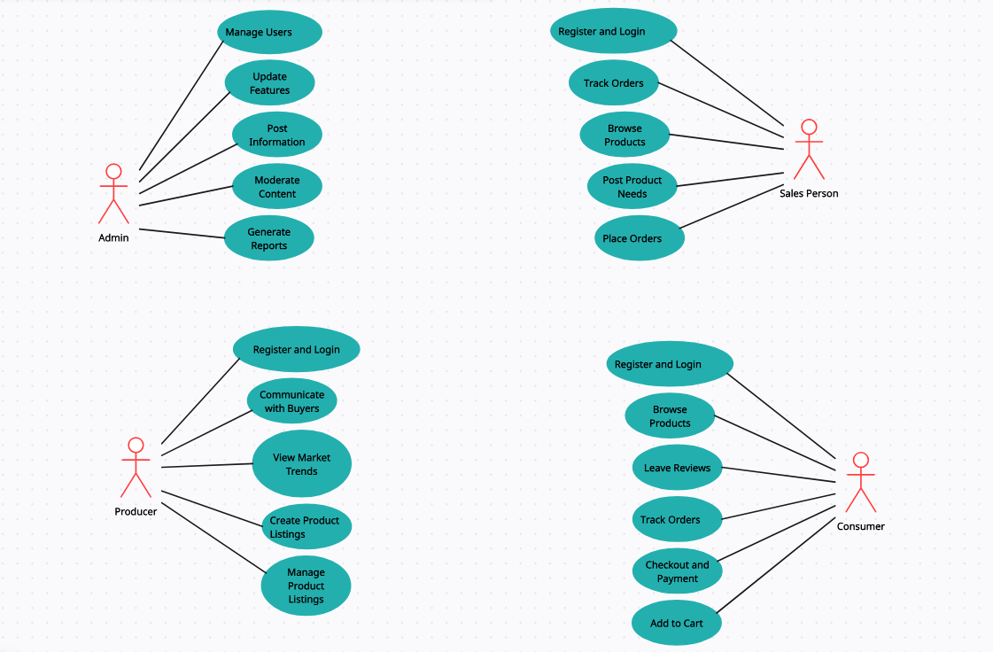**4.1.4 Use case Diagram**

**4.2 Activity Diagram**

The activity diagram for **Sustainableshop Blueprint: Organic Farming**illustrates the dynamic aspects of the system by capturing the workflow of various activities and actions performed by different user roles. This diagram provides a visual representation of the sequence of actions, decisions, and interactions between the four primary user roles: Admin, Producer (Farmer), Sales Person (Wholesaler/Retailer), and Consumer. The activity diagram helps in understanding the overall process flow, the roles involved, and the sequence of operations that need to be performed to achieve specific objectives.

**4.2.1 Overview**

The **Sustainableshop Blueprint: Organic Farming** activity diagram is divided into four main swimlanes, each representing a different user role. The activities and actions taken by these roles are laid out sequentially to depict the flow of tasks and interactions. Below is a detailed description of the activities within each swimlane.

**4.2.2 Admin Activities**

The admin is responsible for maintaining and managing the system. The admin’s activities include:

* **Post Information**: Admin posts updates about recent technology, farming methods, and market trends.
* **Manage Users**: Admin handles user registrations, account management, and user roles.
* **Update Features**: Admin adds new features and functionalities to the system.
* **Moderate Content**: Admin reviews and moderates the content posted by users to ensure compliance with platform guidelines.
* **Generate Reports**: Admin generates various reports related to system usage, sales data, and user activities for analysis and decision-making.

**4.2.3 Producer (Farmer) Activities**

Producers or farmers use the system to advertise their products and connect with potential buyers. Their activities include:

* **Register/Login**: Producers register and log in to the platform.
* **Create Product Listings**: Producers create detailed listings of their products, including names, rates, and quantities.
* **Manage Product Listings**: Producers update or remove their product listings as needed.
* **View Market Trends**: Producers access information about current market trends to make informed decisions.
* **Communicate with Buyers**: Producers interact with sales persons and consumers to negotiate sales and provide additional product information.

**4.2.4 Sales Person (Wholesaler/Retailer) Activities**

Sales persons facilitate the distribution of agricultural products by interacting with producers and consumers. Their activities include:

* **Register/Login**: Sales persons register and log in to the platform.
* **Browse Products**: They browse through the product listings created by producers.
* **Post Product Needs**: Sales persons post their requirements for specific products.
* **Place Orders**: They place orders for the products they need.
* **Track Orders**: Sales persons track the status of their orders.
* **Communicate with Producers**: They engage in communication with producers to finalize transactions and address any queries.

**4.2.5 Consumer Activities**

Consumers use the platform to purchase agricultural products directly from producers. Their activities include:

* **Register/Login**: Consumers register and log in to the platform.
* **Browse Products**: They browse through the available product listings.
* **Add to Cart**: Consumers add selected products to their shopping cart.
* **Checkout and Payment**: They proceed to check out and make payments for their purchases.
* **Track Orders**: Consumers track the delivery status of their orders.
* **Leave Reviews**: They leave reviews and feedback on the products they have purchased.

**4.2.6 Workflow and Interaction**

The activity diagram highlights the interaction between different user roles, showcasing how the activities of one role influence the actions of another. For instance, when a producer creates a product listing, it becomes available for browsing by sales persons and consumers. Similarly, the Admin's role in moderating content ensures that all user-generated content adheres to platform standards.

Overall, the activity diagram provides a comprehensive view of the functional flow within **Sustainableshop Blueprint: Organic Farming**, enabling stakeholders to understand the system's operational dynamics and the interactions between various user roles. This understanding is crucial for identifying potential bottlenecks, improving user experience, and ensuring the smooth functioning of the e-commerce platform for organic farming products.

**4.2.7 Activity Diagram:**

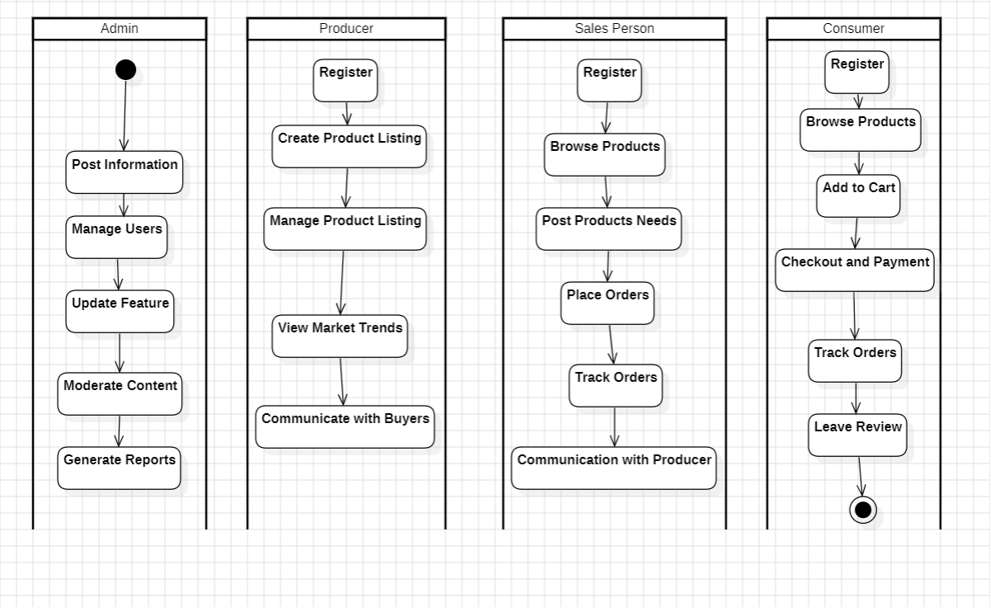

**4.3 Class Diagram for Sustainableshop Blueprint: Organic Farming**

The class diagram for **Sustainableshop Blueprint: Organic Farming** depicts the structure of the system by illustrating the classes, their attributes, methods, and the relationships between them. This diagram provides a visual representation of the key components and their interactions within the e-commerce platform for organic farming products.

**4.3.1 Classes and Their Attributes**

1. **Admin**:
   * Attributes: adminID, name, email, password
   * Methods: postInformation(), manageUsers(), updateFeatures(), moderateContent(), generateReports()
2. **Producer (Farmer)**:
   * Attributes: producerID, name, email, password, farmLocation
   * Methods: createListing(), manageListing(), viewMarketTrends(), communicateWithBuyers()
3. **Sales Person (Wholesaler/Retailer)**:
   * Attributes: salesPersonID, name, email, password, businessLocation
   * Methods: browseProducts(), postProductNeeds(), placeOrders(), trackOrders(), communicateWithProducers()
4. **Consumer**:
   * Attributes: consumerID, name, email, password, address
   * Methods: browseProducts(), addToCart(), checkoutAndPay(), trackOrders(), leaveReviews()
5. **Product**:
   * Attributes: productID, productName, productRate, quantity, producerID
   * Methods: updateProductDetails()
6. **Order**:
   * Attributes: orderID, productID, quantity, totalPrice, orderDate, status, consumerID
   * Methods: updateOrderStatus()
7. **Review**:
   * Attributes: reviewID, rating, comment, productID, consumerID
   * Methods: addReview(), editReview(), deleteReview()

**4.3.2 Relationships**

* **Producer-Product**: One producer can produce multiple products.
* **Product-Order**: One order can contain multiple products.
* **Consumer-Order**: One consumer can place multiple orders.
* **Product-Review**: One product can have multiple reviews.

**4.3.3 Diagram Representation**

The class diagram visually represents the structure of **Sustainableshop Blueprint: Organic Farming**, showcasing the classes and their attributes, methods, and relationships. It illustrates how producers, sales persons, consumers, products, orders, and reviews are interconnected within the system. Through associations, aggregations, and compositions, the diagram captures the flow of data and interactions between different components of the e-commerce platform.

**4.3.4 Class Diagram**

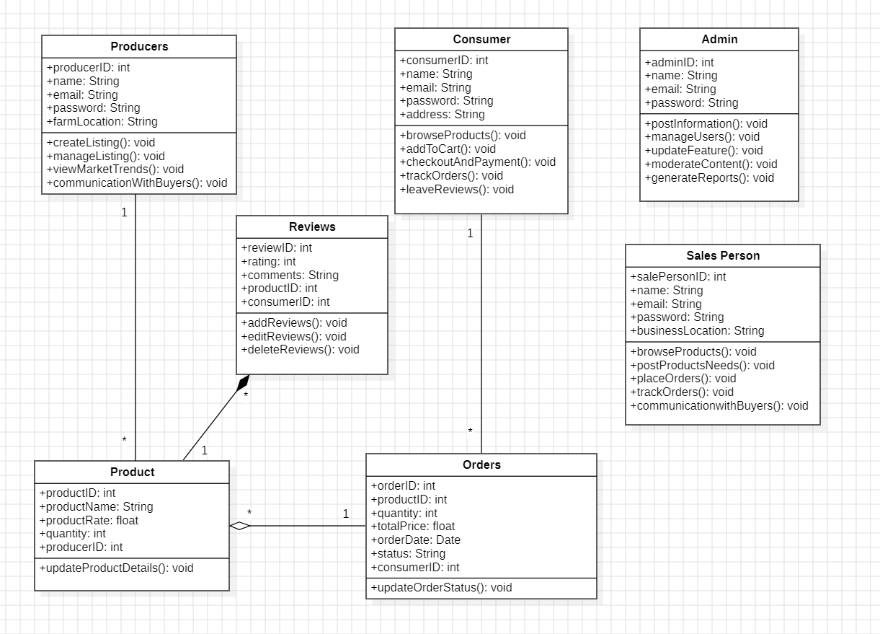

**4.4 Sequence Diagram**

**4.4.1 Scenario 1: Consumer Browsing and Buying Products**

In this scenario, we illustrate the typical interactions between a consumer and the various components of the **Sustainableshop Blueprint: Organic Farming** system as they browse products, add products to their cart, place an order, and leave a review. The sequence diagram for this scenario includes interactions between the Consumer actor and the Product, Cart, Order, and Review objects. Each step is essential for facilitating a smooth user experience on the platform.

**1. Browsing Products**

* **Message:** browseProducts
* **From:** Consumer
* **To:** Product
* **Description:** The sequence begins with the Consumer browsing the available products on the platform. This interaction is initiated when the Consumer selects the option to view the product listings. The browseProducts message is sent from the Consumer to the Product object, which retrieves and displays a list of available products for the Consumer to view.

**2. Adding Products to Cart**

* **Message:** addToCart
* **From:** Consumer
* **To:** Cart
* **Description:** After browsing the products, the Consumer decides to purchase an item. The Consumer selects a product and adds it to their shopping cart. This action sends an addToCart message from the Consumer to the Cart object, which updates the cart to include the selected product. The cart maintains a list of products that the Consumer intends to purchase.

**3. Placing an Order**

* **Message:** placeOrder
* **From:** Consumer
* **To:** Order
* **Description:** Once the Consumer has finished adding products to their cart, they proceed to place an order. The Consumer initiates the checkout process by sending a placeOrder message to the Order object. This message includes the details of the products in the cart, the quantity of each item, and the delivery information. The Order object processes this information and creates a new order entry in the system.

**4. Confirming Order**

* **Message:** confirmOrder
* **From:** Order
* **To:** Consumer
* **Description:** After the Order object processes the order, it sends a confirmOrder message back to the Consumer. This message serves as a confirmation that the order has been successfully placed and includes details such as the order number, estimated delivery date, and a summary of the purchased items. This confirmation provides assurance to the Consumer that their order is being processed.

**5. Leaving a Review**

* **Message:** addReview
* **From:** Consumer
* **To:** Review
* **Description:** Following the delivery and use of the purchased products, the Consumer may decide to leave feedback on their experience. The Consumer sends an addReview message to the Review object, which records the Consumer's review, rating, and comments about the product. This review is then associated with the specific product and made available for other consumers to read.

**Conclusion**

This scenario encapsulates the essential steps a Consumer takes when interacting with the **Sustainableshop Blueprint: Organic Farming** platform to browse, purchase, and review products. Each interaction is crucial for providing a seamless and user-friendly experience. By clearly defining and illustrating these interactions in the sequence diagram, we ensure that the system meets the needs and expectations of the consumers, facilitating effective e-commerce transactions within the organic farming marketplace.

**Consumer Browsing and Buying Products**

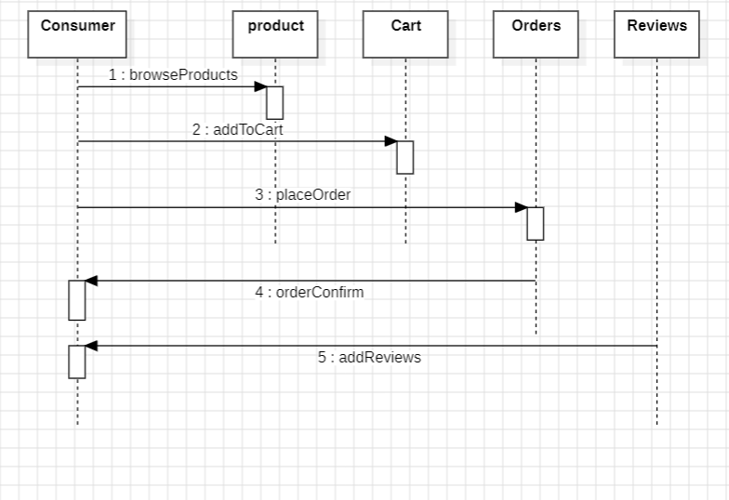

**4.4.2 Scenario 2: Producer Managing Products**

In this scenario, we detail the interactions between a Producer and the system components involved in managing product listings on the SustainableShop Blueprint: Organic Farming platform. The Producer performs key actions such as adding new products, updating product details, and deleting products from the listing. These interactions ensure that the Producer can effectively manage their inventory and keep their product information current for potential buyers.

**1. Adding a New Product**

* **Message:** addProduct
* **From:** Producer
* **To:** Product
* **Description:** The scenario begins with the Producer adding a new product to the platform. The Producer initiates this action by sending an addProduct message to the Product object. This message includes details such as the product name, description, price, quantity, and any other relevant information. The Product object processes this data and creates a new product entry in the system, making it available for consumers and salespersons to view and purchase.

**2. Updating Product Details**

* **Message:** updateProduct
* **From:** Producer
* **To:** Product
* **Description:** Over time, the Producer may need to update the details of an existing product, such as changing the price, updating the description, or adjusting the available quantity. The Producer sends an updateProduct message to the Product object, specifying the updated information. The Product object then processes this update, ensuring that the latest information is reflected in the product listing for consumers and salespersons.

**3. Deleting a Product**

* **Message:** deleteProduct
* **From:** Producer
* **To:** Product
* **Description:** If a product is no longer available or the Producer decides to stop selling it, the Producer can remove it from the platform. The Producer sends a deleteProduct message to the Product object. This message specifies the product to be removed. The Product object processes the request and deletes the product from the listing, ensuring that it is no longer available for purchase by consumers and salespersons.

**Conclusion**

This scenario outlines the fundamental actions a Producer takes to manage their product listings on the SustainableShop Blueprint: Organic Farming platform. By adding new products, updating existing product details, and deleting products, Producers can maintain an accurate and up-to-date inventory. These interactions are critical for providing consumers and salespersons with current information, facilitating smooth transactions, and ensuring a reliable marketplace for organic farming products. By documenting and illustrating these interactions in the sequence diagram, we ensure that the system supports the Producers' needs in managing their products efficiently.

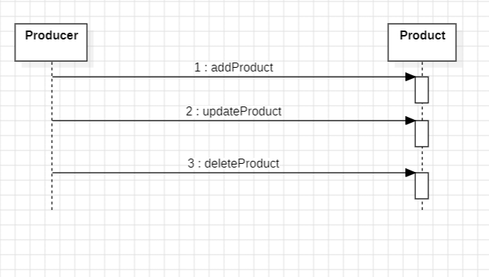

**4.4.3 Scenario 3: Sales Person Handling Orders**

In this scenario, we illustrate the interactions between a Sales Person and the system components involved in handling orders on the SustainableShop Blueprint: Organic Farming platform. The Sales Person is responsible for managing customer orders, placing orders on behalf of customers, and ensuring that all orders are processed smoothly. These interactions are crucial for maintaining an efficient and customer-friendly order management process.

**1. Placing an Order on Behalf of a Customer**

* **Message:** placeOrder
* **From:** Sales Person
* **To:** Order
* **Description:** The scenario begins with the Sales Person placing an order on behalf of a customer. This is particularly useful when dealing with wholesale buyers or assisting customers who prefer personal service. The Sales Person initiates this action by sending a placeOrder message to the Order object. This message includes details such as the customer's information, the products being ordered, quantities, and delivery instructions. The Order object processes this data and creates a new order entry in the system.

**2. Managing Customer Orders**

* **Message:** manageOrders
* **From:** Sales Person
* **To:** Order
* **Description:** Throughout the order lifecycle, the Sales Person may need to manage various aspects of customer orders. This includes updating order statuses, modifying order details, handling special requests, and addressing any issues that arise. The Sales Person sends a manageOrders message to the Order object, specifying the actions to be taken. The Order object processes these instructions, ensuring that the orders are updated and managed according to the Sales Person's input.

**Conclusion**

This scenario outlines the essential tasks performed by a Sales Person in handling orders on the SustainableShop Blueprint: Organic Farming platform. By placing orders on behalf of customers and managing existing orders, the Sales Person ensures that the order process runs smoothly and efficiently. These interactions are vital for maintaining high levels of customer satisfaction and operational efficiency. By documenting and illustrating these interactions in the sequence diagram, we ensure that the system supports the Sales Person's needs in managing customer orders effectively.

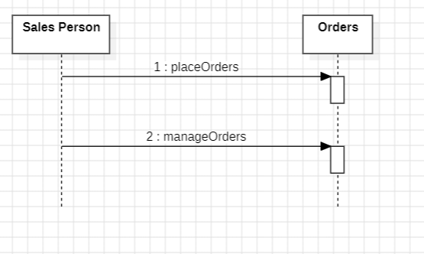

**4.5 Statechart Diagram**

The statechart diagram for the SustainableShop Blueprint: Organic Farming platform represents the various states an Order object can be in throughout its lifecycle, as well as the transitions between these states triggered by specific events. This diagram is crucial for understanding the dynamic behavior of the order processing system and ensuring smooth transitions from one state to another, thus providing a seamless user experience.

**4.5.1 States and Transitions**

1. **Initial State:**
   * The order process begins at the initial state, where no action has yet been taken by the consumer or the system.
2. **Browsing:**
   * **Transition:** Browse Products
   * **Description:** The consumer is browsing through the available products on the platform. This state is entered when the consumer initiates product browsing.
3. **Adding to Cart:**
   * **Transition:** Add to Cart
   * **Description:** The consumer adds selected products to their shopping cart. This transition occurs when a product is added to the cart from the browsing state.
4. **Placing Order:**
   * **Transition:** Place Order
   * **Description:** The consumer proceeds to checkout and initiates the order placement process. This state is reached when the consumer decides to purchase the items in their cart.
5. **Order Confirmation:**
   * **Transition:** Order Confirmed
   * **Description:** The system confirms the order details and acknowledges the order placement. The order transitions to this state once it is successfully placed.
6. **Payment:**
   * **Transition:** Payment Made
   * **Description:** The consumer completes the payment for the order. The order enters this state after the payment process is completed.
7. **Order Processing:**
   * **Transition:** Process Order
   * **Description:** The system processes the order, preparing it for shipment. This state involves verifying order details and preparing the items for dispatch.
8. **Shipped:**
   * **Transition:** Order Shipped
   * **Description:** The order is shipped to the consumer. This transition occurs once the order leaves the warehouse and is on its way to the delivery address.
9. **Delivered:**
   * **Transition:** Order Delivered
   * **Description:** The order is delivered to the consumer. This state is reached when the consumer receives the order.
10. **Reviewed:**
    * **Transition:** Add Review
    * **Description:** The consumer leaves a review for the purchased products. This state is entered when the consumer provides feedback on the order.
11. **Completed:**
    * **Transition:** Complete Order
    * **Description:** The order process is completed, and no further actions are required. This final state signifies the end of the order lifecycle.
12. **Final State:**
    * The order process reaches the final state when all actions have been completed, and no further transitions are expected.

**4.5.2 Diagram Representation**

The statechart diagram visually represents these states and transitions, illustrating the flow of an order from initiation to completion. Each state is depicted as a rounded rectangle, while transitions are shown as arrows connecting the states. The labels on the transitions indicate the events that trigger the movement from one state to another.

By documenting the order lifecycle in a statechart diagram, we can ensure a clear understanding of the system's behavior and the various stages an order goes through on the SustainableShop Blueprint: Organic Farming platform. This helps in identifying potential areas for improvement and ensuring a smooth and efficient order management process.

**4.5.3 State Chart Diagram:**

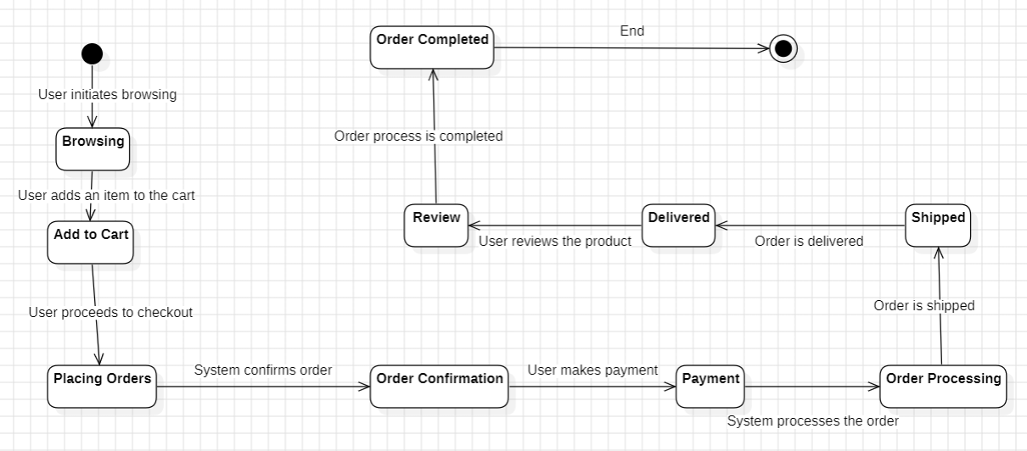

**4.6 Data Flow Diagram (DFD) Level 0**

The Level 0 Data Flow Diagram (DFD), also known as the context diagram, provides a high-level overview of the SustainableShop Blueprint: Organic Farming platform. This diagram illustrates the system as a single process and highlights its interactions with external entities such as Consumers, Producers, Salespersons, and Admin. The primary purpose of the Level 0 DFD is to visualize the major data flows between these entities and the system, facilitating a clear understanding of the overall functionality and data exchanges within the platform.

**4.6.1 External Entities and Interactions**

1. **Consumer:**
   * **Input to System:**
     + **Product Search:** Consumers browse through available organic products.
     + **Add to Cart:** Consumers add selected products to their shopping cart.
     + **Place Order:** Consumers proceed to checkout and place orders for the items in their cart.
     + **Payment Details:** Consumers provide payment information to complete their purchases.
     + **Leave Review:** Consumers leave reviews for purchased products.
   * **Output from System:**
     + **Product Listings:** The system provides a list of available organic products.
     + **Order Confirmation:** The system confirms the successful placement of an order.
     + **Payment Confirmation:** The system confirms the successful completion of a payment.
     + **Review Acknowledgment:** The system acknowledges receipt of a product review.
2. **Producer:**
   * **Input to System:**
     + **Add/Update/Delete Product:** Producers manage their product listings by adding new products, updating existing ones, or deleting those no longer available.
   * **Output from System:**
     + **Product Listings:** The system updates the product listings based on the producer's inputs.
     + **Sales Reports:** The system generates sales reports for the producer.
     + **Order Requests:** The system notifies the producer of new order requests.
3. **Salesperson:**
   * **Input to System:**
     + **Place Order:** Salespersons place orders on behalf of customers, particularly wholesale buyers.
     + **Manage Order:** Salespersons manage existing orders, including updating order statuses and handling special requests.
   * **Output from System:**
     + **Order Confirmation:** The system confirms orders placed by the salesperson.
     + **Order Status Updates:** The system provides updates on the status of managed orders.
4. **Admin:**
   * **Input to System:**
     + **Update System Features:** Admins update the platform with new features and improvements.
     + **Add Market Information:** Admins add information about market trends and prices.
     + **Add Success Stories:** Admins post success stories to motivate and inform users.
   * **Output from System:**
     + **System Updates:** The system reflects the latest updates and features added by the admin.
     + **Market Reports:** The system provides updated market information to users.
     + **Success Stories:** The system displays success stories for user inspiration.

**4.6.2 Diagram Representation**

The Level 0 DFD represents the SustainableShop Blueprint: Organic Farming platform as a central process interacting with the aforementioned external entities. The data flows are depicted as arrows, indicating the direction of data exchange. Each arrow is labeled to specify the type of data being transmitted, ensuring clarity in the diagram.

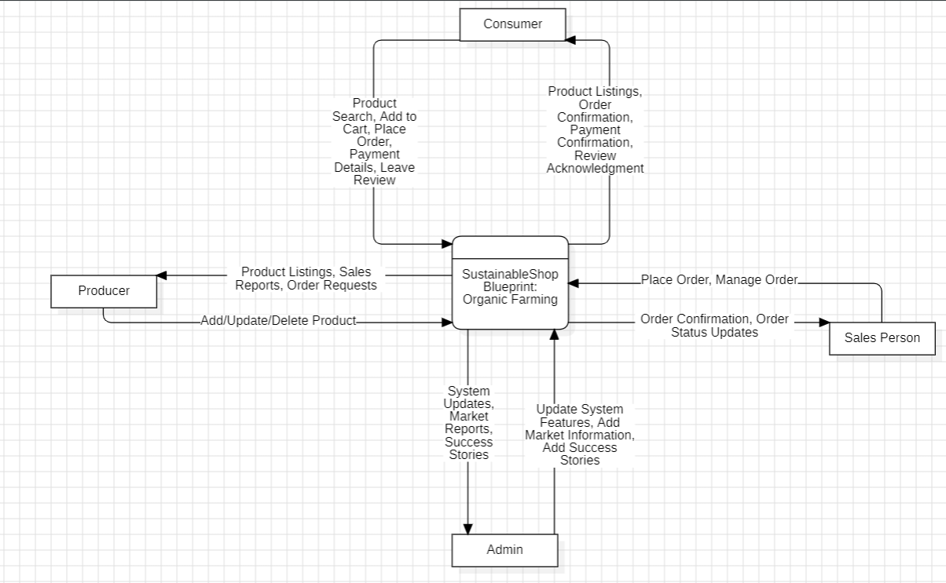

**4.6.3 Conclusion**

The Level 0 DFD for the SustainableShop Blueprint: Organic Farming platform provides a comprehensive overview of the system's interactions with its external entities. By illustrating the primary data flows and interactions, this diagram serves as a foundational tool for understanding the system's overall functionality. It helps stakeholders visualize how data is exchanged between the system and its users, ensuring a clear understanding of the system's operations and facilitating further detailed analysis in subsequent levels of DFDs.

**4.7 Data Flow Diagram (DFD) Level 1**

The Level 1 Data Flow Diagram (DFD) for the SustainableShop Blueprint: Organic Farming platform delves deeper into the system, breaking down the single process represented in the Level 0 DFD into more detailed sub-processes. This diagram highlights the major internal processes of the system and shows how data flows between them, providing a clearer picture of the system's internal workings. By expanding on the Level 0 DFD, the Level 1 DFD offers a more granular view of the system's functionality and interactions.

**4.7.1 Major Internal Processes**

1. **Product Management**
   * **Processes:**
     + **Add Product:** Producers can add new products to the platform.
     + **Update Product:** Producers can update details of existing products.
     + **Delete Product:** Producers can remove products from the platform.
   * **Data Flows:**
     + **Input:** Product details from Producers.
     + **Output:** Updated product listings to Consumers and Salespersons.
2. **Order Management**
   * **Processes:**
     + **Place Order:** Consumers and Salespersons place orders for products.
     + **Process Order:** The system processes the placed orders.
     + **Update Order Status:** The system updates the status of orders (e.g., confirmed, shipped, delivered).
   * **Data Flows:**
     + **Input:** Order details from Consumers and Salespersons.
     + **Output:** Order confirmations, status updates to Consumers, Salespersons, and Producers.
3. **Payment Processing**
   * **Processes:**
     + **Process Payment:** The system processes payment details provided by Consumers.
     + **Confirm Payment:** The system confirms successful payments.
   * **Data Flows:**
     + **Input:** Payment details from Consumers.
     + **Output:** Payment confirmations to Consumers and Salespersons.
4. **User Management**
   * **Processes:**
     + **Register User:** New users (Consumers, Producers, Salespersons) register on the platform.
     + **Login User:** Existing users log in to the platform.
   * **Data Flows:**
     + **Input:** User registration and login details.
     + **Output:** User authentication status and account details.
5. **Admin Management**
   * **Processes:**
     + **Update Features:** Admins update the platform with new features.
     + **Post Market Information:** Admins add market information such as prices and trends.
     + **Publish Success Stories:** Admins post success stories to motivate and inform users.
   * **Data Flows:**
     + **Input:** New feature details, market information, success stories from Admins.
     + **Output:** Updated platform features, market reports, and success stories to all users.

**4.7.2 Diagram Representation**

The Level 1 DFD represents these major internal processes as separate sub-processes within the central system. Data flows between these sub-processes and external entities are depicted to illustrate how information is exchanged and processed within the system.

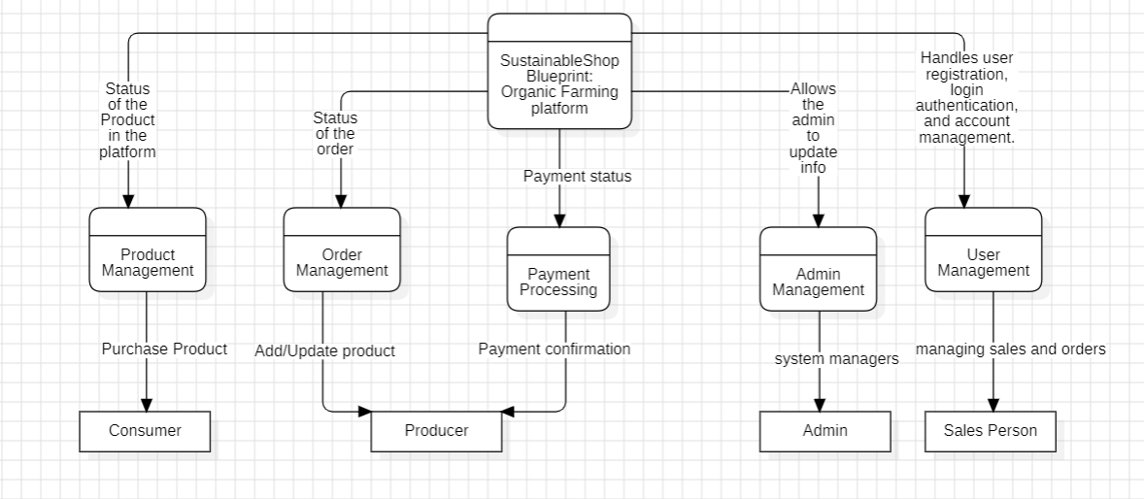

**4.7.3 Conclusion**

The Level 1 DFD for the SustainableShop Blueprint: Organic Farming platform provides a detailed view of the system's internal processes and their interactions. By breaking down the single process from the Level 0 DFD into specific sub-processes, this diagram offers a clearer understanding of how the system operates and manages data flows. It highlights the key functions of the system and the way data is processed and exchanged, ensuring a comprehensive understanding of the system's architecture and functionality. This detailed view is crucial for further system analysis, development, and optimization.

**4.8 Entity-Relationship (ER) Diagram**

The Entity-Relationship (ER) diagram for the SustainableShop Blueprint: Organic Farming platform provides a graphical representation of the database schema, illustrating the entities, attributes, and relationships that comprise the system's data model. The diagram captures the essential components of the platform's database structure, facilitating a clear understanding of the data organization and interconnections within the system.

**4.8.1 Entities and Attributes:**

1. **Product:**
   * Represents the organic products available on the platform.
   * Attributes may include ProductID, Name, Description, Price, Quantity, ProducerID, etc.
2. **Order:**
   * Represents individual orders placed by consumers or salespersons.
   * Attributes may include OrderID, Date, TotalAmount, Status, ConsumerID, SalespersonID, etc.
3. **User:**
   * Represents users registered on the platform.
   * Attributes may include UserID, Username, Password, Email, UserType, etc.
4. **Review:**
   * Represents the reviews left by consumers for purchased products.
   * Attributes may include ReviewID, ProductID, UserID, Rating, Comment, etc.
5. **Admin:**
   * Represents administrators managing the platform.
   * Attributes may include AdminID, Username, Password, Email, etc.
6. **Category:**
   * Represents categories or types of organic products.
   * Attributes may include CategoryID, Name, Description, etc.

**4.8.2 Relationships**:

1. **Product-Producer Relationship:**
   * A one-to-many relationship between Product and Producer entities.
   * Indicates that one producer can produce multiple products.
2. **Order-User Relationship:**
   * A many-to-one relationship between Order and User entities (Consumer or Salesperson).
   * Indicates that multiple orders can be placed by a single user.
3. **Review-User Relationship:**
   * A many-to-one relationship between Review and User entities (Consumer).
   * Indicates that multiple reviews can be written by a single user.
4. **Product-Category Relationship:**
   * A many-to-many relationship between Product and Category entities.
   * Indicates that a product can belong to multiple categories, and a category can have multiple products.

**4.8.3 Diagram Representation:**

The ER diagram visually represents these entities, attributes, and relationships using standard symbols and notation. It provides a comprehensive overview of the database schema, guiding database design and implementation efforts for the SustainableShop Blueprint: Organic Farming platform.

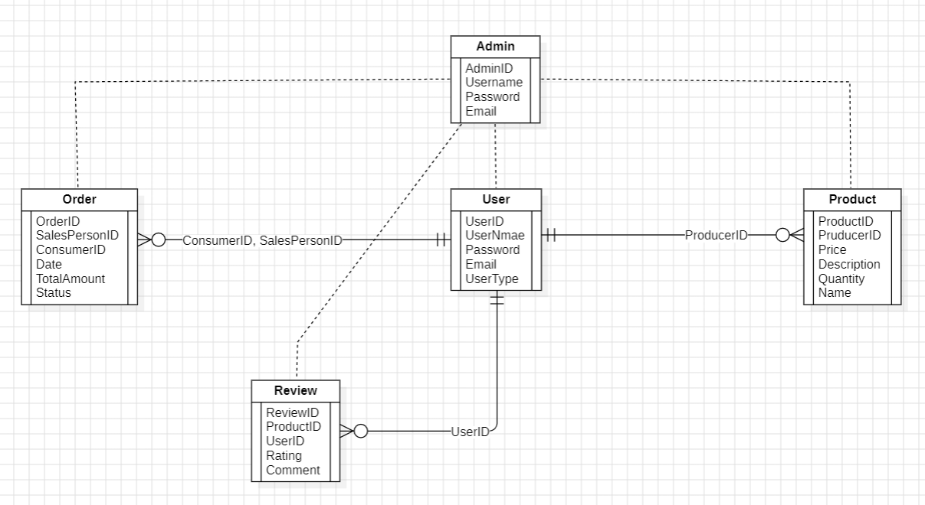

**4.8.4 Conclusion:**

The ER diagram serves as a valuable tool for understanding the data model of the SustainableShop Blueprint: Organic Farming platform. By capturing the entities, attributes, and relationships within the system, the diagram aids in database design, development, and maintenance, ensuring efficient data management and retrieval capabilities for the platform.

1. **System Architecture for SustainableShop Blueprint: Organic Farming**

**5.1 Overview**

The system architecture for the SustainableShop Blueprint: Organic Farming platform is designed to be robust, scalable, and secure, catering to the needs of producers, consumers, salespersons, and administrators. This section outlines the architecture, detailing its components, their interactions, and the technologies employed.

**5.2 Architectural Design**

1. **Client-Server Architecture:** The system follows a client-server architecture where the client is a mobile-based application, and the server is a web-based backend system. This separation ensures a clear distinction between the user interface and the data processing layers, enhancing maintainability and scalability.
2. **Three-Tier Architecture:** The platform adopts a three-tier architecture comprising the Presentation Layer, Application Layer, and Data Layer. This layered approach allows for modular development, easy maintenance, and the ability to scale each layer independently.
   1. **Layers of the Architecture**
3. **Presentation Layer:**
   * **Components:** Mobile application (Android/iOS), Web Interface
   * **Technologies:** HTML, CSS, JavaScript, React Native (for mobile app), RESTful APIs
   * **Functions:** This layer is responsible for interacting with the users (farmers, consumers, salespersons, and administrators). It handles user input, displays information, and provides a responsive and intuitive user interface.
4. **Application Layer:**
   * **Components:** Web server, Application server
   * **Technologies:** Node.js, Express.js, Spring Boot, Django
   * **Functions:** This layer contains the business logic of the application. It processes user requests, executes transactions, and implements the rules and workflows that govern the application’s behavior. It communicates with both the presentation and data layers through well-defined APIs.
5. **Data Layer:**
   * **Components:** Database server, Data storage
   * **Technologies:** MySQL, PostgreSQL, MongoDB
   * **Functions:** The data layer is responsible for storing and retrieving data. It manages the database operations such as CRUD (Create, Read, Update, Delete) activities and ensures data integrity, security, and consistency.
   1. **Key Components and Interactions**
6. **User Management:**
   * Handles user authentication, authorization, and profile management.
   * Ensures secure access control using technologies like OAuth 2.0, JWT (JSON Web Tokens)
7. **Product Management:**
   * Allows producers to list products and manage inventory.
   * Enables consumers to browse, search, and filter products.
8. **Order Management:**
   * Facilitates order creation, tracking, and management for consumers and salespersons.
   * Processes payments and manages order statuses.
9. **Review System:**
   * Allows consumers to review products, providing ratings and feedback.
   * Helps producers and administrators monitor product performance and customer satisfaction.
10. **Admin Management:**
    * Provides administrative functions such as system monitoring, user management, and content management.
    * Admins can update features, add new information about technology and methods, manage market prices, and highlight success stories.

**5.5. Communication and Data Flow**

1. **Client-Server Communication:**
   * Utilizes RESTful APIs for communication between the client application and the server.
   * Ensures secure data transmission using HTTPS.
2. **Server-Database Communication:**
   * The application server interacts with the database server using SQL queries or ORM (Object-Relational Mapping) frameworks.
   * Ensures data integrity and security through transactions and access controls.

**5.6. Security Considerations**

1. **Data Encryption:**
   * All sensitive data is encrypted in transit using SSL/TLS.
   * Data at rest is encrypted using database encryption techniques.
2. **Authentication and Authorization:**
   * Implements robust user authentication mechanisms such as multi-factor authentication.
   * Uses role-based access control (RBAC) to ensure users have appropriate permissions.
3. **Data Backup and Recovery:**
   * Regular data backups are performed to prevent data loss.
   * Disaster recovery plans are in place to ensure business continuity.

**5.7 Conclusion**

The system architecture for the SustainableShop Blueprint: Organic Farming platform is designed to provide a seamless, efficient, and secure experience for all users. By leveraging modern technologies and best practices, the architecture supports the platform’s goals of connecting producers and consumers, managing agricultural products, and promoting sustainable farming practices.

1. **Acknowledgment**

We would like to extend our sincere appreciation to all individuals and teams who have contributed to the development of this Software Requirements Specification (SRS) document for the SustainableShop Blueprint: Organic Farming platform.

Our gratitude goes out to the project managers, developers, testers, stakeholders, and all other parties involved in shaping the vision and requirements of this project. Their expertise, dedication, and collaboration have been invaluable in capturing the essential functionalities, defining user roles, and outlining the system architecture.

1. **Closing Statement**

In conclusion, this SRS document serves as a comprehensive guide to the requirements, functionalities, and constraints of the SustainableShop Blueprint: Organic Farming platform. It provides a solid foundation for the design, development, and implementation phases of the project.

As we move forward, we are committed to ensuring that all project requirements are met with precision and that the final product aligns seamlessly with the envisioned solution. We welcome further collaboration, feedback, and input from all stakeholders to ensure the success and sustainability of this initiative.

Thank you for your attention, dedication, and support throughout this process. Together, we look forward to bringing the SustainableShop Blueprint: Organic Farming platform to fruition and making a positive impact in the realm of organic farming and sustainable agriculture.